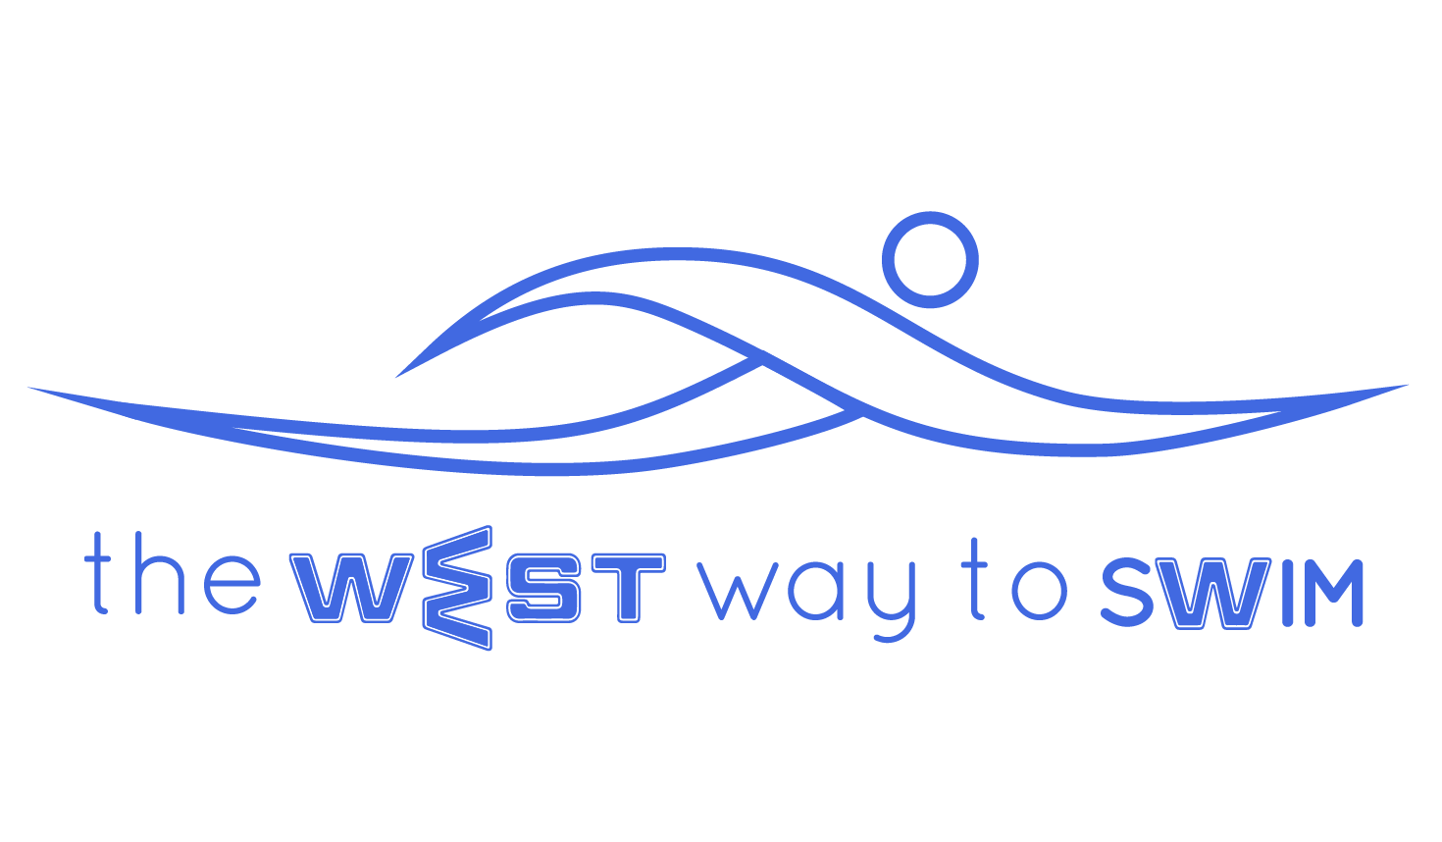
7.0 Goal of exercise 7- Changing swimming pace while mastering the number of strokes per length, knowing to increase and decrease the number of strokes. We will learn to swim 100 meters at a fixed pace with 20 seconds rest between.
No | The Drill & Goals | min | WEST Key Principles | From theory to practice
7.1 | 200-400 with fins- one length kicking on your back with arms in streamline position, one length freestyle. | 7 |  | Swim with fins - one length, kicking on your back with arms in streamline position on the waterline, and one length freestyle, maintaining 12 strokes per length..  If you sing during backstroke try to inhale more air and try to float first and then stretch your hands.
7.2 | 4-8X25, 15 second rest, note the body breathing position and end of pull through when breathing. | 6 | KP12- Body position when breathing.  KP7- End of underwater pull | Swim 4-8 25m lengths while thinking of the 2 key principles:  Body position when breathing:  There’s no need to pause in the position, but you must feel that one eye is in the water and the nose and mouth are out of the water.  End of underwater pull according to your personal WEST:  A - Finish pull when palm is near the inner thigh  B - Near the middle part of the thigh  C - Outer thigh  15 sec rest between every 25m.
7.3 | 8X(2X25) counting strokes- One length fast! + One length slow. The slow length always has less strokes than the fast one | 10-  15 |  | Swim 8 times 25m slowly and 25m fast, while maintaining an exact stroke number on the fast lengths, while in the slow lengths the number of strokes decreases every time as you lengthen your glide.  Fast length should be at 85% max, in order not to “burn” the muscle.  Example: 1st length: 21 strokes, 2nd length: 20 strokes, and then 21 and 19, 21 and 18, 21 and 17 and so on,  Rest for 20 sec between each 50m.  He important thing in this drill is the number of sets, while the overall time can be between 10-15 min.
7.4 | 200-300 backstroke & freestyle with fins | 5 |  | Swim ⅓ length freestyle with fins. Roll gently to supine position and do ⅓ backstroke, then return to prone position and do the last ⅓ freestyle. Try to transition without working your neck.
7.5 | (3-4X100)X2 a fixed Exit time interval  2nd set increasing pace in 100m | 20 |  | 1st set: Swim 3-4 times 100m, on a fixed exit time. For example: If you swam 100m in 2:26 min, exit for the every next 100m at 2:50, no matter how fast you swam it.  2nd set: Swim 3-4 times 100m, on a fixed exit time, only this time swim each 100m exactly 3 seconds faster than the one before. For example: 2:26 (exit on 2:50), 2:23, 2:20, 2:17. Keep same exit time even though you rest less.
7.6 | 3-5X100 with fins with a fixed exit time, trying to maintain 12 strokes per length, while increasing the swimming pace (2 seconds faster on each 100 meters). | 10 |  | Swim 3-5 times 100m with fins (as many as you can get within 10 min). During the whole drill maintain a constant 12-13 strokes per length, and swim every 100m exactly 2 sec faster than the one before.  To succeed in this drill you have to start the first 100m slowly.  Exit time is constant at 2:00 min, 2:15, 2:30 or 3:00 min, according to your choice.
7.7 | Arm stretches. | 8 |  | Swim 50m very slowly, followed by arm stretches of your choice.
7.8 Weekly Tip: During the main sets we will attempt to think about swimming fast but without burning out your body. You must find a balance between effort and recovery. By this time you should know your exit time and the exact pace you need to swim in.

